Authored By: Mark Glassett

**TABLE OF CONTENTS Page**

1. ABSTRACT 1

2. OBJECTIVE 1

3. RESULTS 1

4. DISCUSSION 3

5. CONCLUSIONS 3

6. RECOMMEMDATIONS 3

7. APPENDIX 4

# ABSTRACT

Zip Pen REF 2525-10 gamma sterile samples were exposed to EO sterilization and accelerated aging to simulate three years and tested for dielectric withstand per ENG-PRT-330 and IEC 60601-2-2. The Zip Pen passed the dielectric withstand tests. The Zip Pen holster passed the dielectric tests. Catalog number 2525-10 was tested. This testing is representative of all REF 2525-XX product family because the test is focused on the hand piece only. The hand piece portion of the Zip Pen is the same on all of the catalog numbers.

# OBJECTIVE

The purpose of this test report is to document that the Zip Pen REF 2525-XX meets the requirements for dielectric withstand per protocol ENG-PRT-330 and IEC 60601-2-2:2009 after exposure to EO sterilization. The purpose of this testing is to show that the Zip Pen is compatible with EO sterilization. This is not an EO sterilization validation.

# RESULTS

The Zip Pen samples for this dielectric withstand test were built at New Deantronics. The samples were REF 2525-10 Lot# S150097. The samples were production product that had been gamma sterilized. The product was sent to EO sterilization and received two exposure cycles of four hours each, refer to Appendix I for sterilization data.

Two cases of 2525-10 with 20 units per case received the treatment outlined below. Of this product, 30 samples were tested per protocol ENG-PRT-330. The test consisted of the following elements:

|  |  |
| --- | --- |
| **Treatment/Test** | **Description** |
| EO exposure | Two EO exposures of 4 hours each, see Appendix I |
| Accelerated aging | Aging at 55°C for 111 days minimum, see Appendix I |
| Megadyne IEC shipping and storage cycle | Temperatures from -40oC to 70oC  Humidity from 15% to 95%, see Appendix II |
| Preconditioning | ASTM D4169 preconditioning at 23°C and 50% humidity for 72 hours, see Appendix II |
| Handling Test #1 | Drop the product 6 times on faces, corners and edges per the protocol, see Appendix II |
| Compression test | Application of compressive force of 210 lbs. per the protocol, see Appendix II |
| Vehicle vibration | High frequency vibration for 10 minutes, see Appendix II |
| Loose load vibration | Low frequency vibration for 40 minutes, see Appendix II |
| Concentrated impact | Impact per ASTM D6344, see Appendix II |
| Handling Test #2 | Drop the product 6 times on faces, corners and edges per the protocol, see Appendix II |
| Continuity Measurement | Tested per IEC 60601-2-2, see Appendix III |
| HF dielectric withstand | Tested per IEC 60601-2-2, HF dielectric test at 6.2 kV (20%) above rated voltage of 5.5kV, see Appendix III |
| Mains Frequency dielectric withstand | Tested per IEC 60601-2-2, Mains dielectric test at 5.0kV (5.5kV converted to RMS and add 1.0kV) , see Appendix III |
| Holster HF dielectric | Test per ENG-PRT-330, see Appendix IV |
| Holster Mains frequency dielectric | Test per ENG-PRT-330, see Appendix IV |

# DISCUSSION

Continuity Measurement: All samples were measured for continuity per the requirements of the protocol. All of the samples passed with the resistance less than 50 ohms when the buttons are depressed and greater than 10,000 ohms when the button is released. Refer to Appendix III for test data.

High Frequency Dielectric: The Zip Pen has a voltage rating of less than or equal to 5,500 Vp. The High Frequency dielectric test was performed at minimum of 6,600 Vp which is 120% of the rated voltage as required by IEC 60601-2-2 clause 201.8.8.3.103. The testing followed the requirements of protocol ENG-PRT-330 and all of the 30 samples passed the requirements of the protocol. Refer to Appendix III for test data.

## Mains Frequency Dielectric: The Mains Frequency dielectric test followed the high frequency test and was performed at 5,000 Vrms which is 1000 Vp above the rated voltage as required by IEC 60601-2-2 clause 201.8.8.3.104. This value is calculated from the rated accessory voltage of 5,500 Vp and dividing by √2 to convert the voltage to Vrms then adding 1,000 volts. The testing followed the requirements of protocol ENG-PRT-330. All of the 30 samples passed the requirements of the protocol. Refer to Appendix III for test data.

Holster High Frequency and Mains Dielectric Test: Holster testing is not required by IEC 60601-2-2. However, the healthcare provider is likely to store the Zip Pen in the holster and it could be inadvertently activated. Therefore it was determined that a holster test was appropriate. The holster samples were tested for High Frequency at 6,600 Vp and at Mains Frequency at 5,000 Vrms and passed both tests. Refer to Appendix IV for test data.

# CONCLUSIONS

This testing demonstrates that the Zip Pen and Holster meets the acceptance criteria of the protocol for dielectric withstand after exposure to EO sterilization and three year accelerated aging.

# RECOMMEMDATIONs

The Zip Pen and Holster meets the requirements for dielectric withstand after exposure to EO sterilization. This testing was done to show compatibility with EO sterilization and is not an EO validation. This testing is intended to support the bulk non-sterile product that is sold to kit packers who routinely use EO sterilization. This report along with other documentation to support catalog items 2525-10BN and 2525-10ECBN will be routed for approval per QA-SOP-013.

# appendix

Appendix I

EO exposure and Aging Documentation



Appendix I Continued

EO exposure and Aging Documentation



Appendix II

Preconditioning and Ship Test Documentation

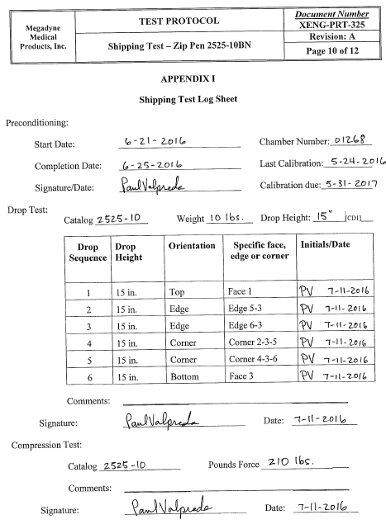

Appendix II Continued

Preconditioning and Ship Test Documentation

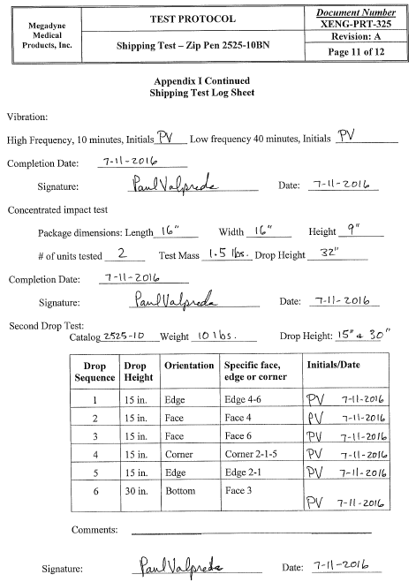

Appendix III

High Frequency, Mains and Continuity Test Data

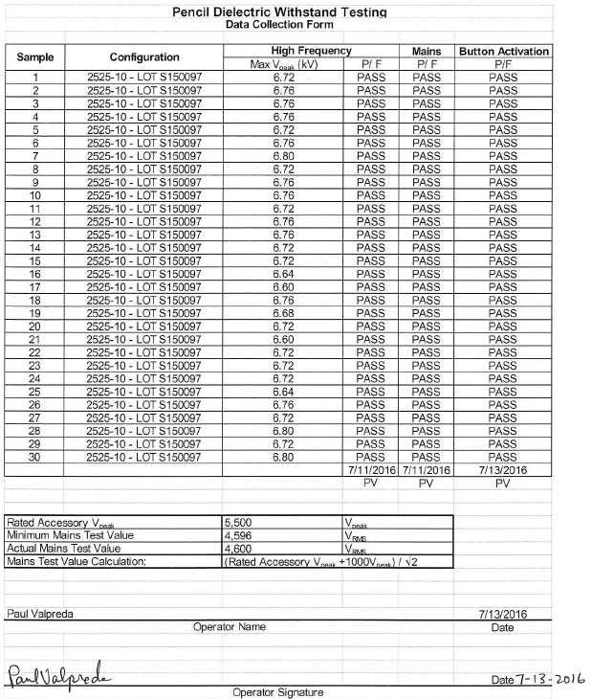

Appendix III Continued

High Frequency, Mains and Continuity Test Data



Appendix IV

Holster Dielectric

